Grace Community Church
Children’s Church

Whenever we are able to have church services, we will meet outside with children ages pre-school through 6th grade (fall of 2020).
We will be doing our best to keep everyone safe and healthy by practicing social distancing and wearing masks. Child-size masks are available – just ask Sheri if you need one.
We’ve been MISSING our kiddos so much, so we’ll give this a try during the message part of the church service.

Our vision is to reach our local
community and the world with
the hope and purpose
that Jesus gives.

Jesus comes to each of us and offers,
“Come to Me.”
Here at Grace Community Church,
we want all to feel welcome,
to get to know Christ better,
and follow Him more closely,
then take His message
out into the world.

Please join us!

An offering plate will not be passed
during our church services.
An offering box is in the back of the auditorium, as well as offering envelopes,
if you would like to make a tax-deductible contribution to the ministries of
Grace Community Church
of Belle Plaine.

Facebook:
Grace Community Church-Belle Plaine

Grace Community Church of Belle Plaine
Website: gracecommbp.org
Email: gracecommbp@gmail.com
Phone: (319) 310-5822
(Sheri Drahos)

Grace Community
Church

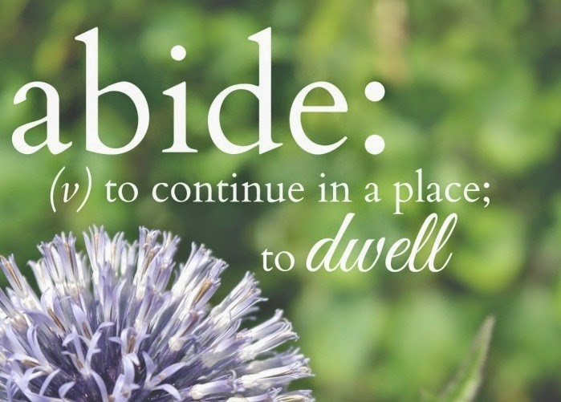

Worship Service
September 5, 2020

Welcome!
Grace Community Church
is delighted that you’ve
joined us for our
Worship Service!

If you’re new to Grace Community,
we invite you to
fill out a Connection Card so we
can get to know you better!
Just place the card in the offering box in the back of the Auditorium.

Anyone interested in receiving biblical counseling can drop a note in the Offering box. We have several counselors at Grace Community who have received training and are able and willing to dig into the scriptures and to work through issues with those who are struggling.
This is a ministry of Grace Community Church and is offered at no charge.

Our Mission:
* To Know Christ
* To Grow in Christ
* To Sow Christ
* To Go into the World with the message of Christ

Scripture
- Luke 11:1-3

The School of Prayer

Four things Jesus taught:

1. Prayer’s primary _____________: The Father’s _________________________.
- His ________________
- His _____________________ and His __________.
- Lastly, our ______________________.

2. Prayer’s _________________: The Father’s ___________________.

3. Prayer’s ___________________: The Father’s _____________________.

4. Prayer’s __________________: The ______________ ________________.

Reflection/Discussion Questions:

1. Why does God delay to answer prayers that ‘for all we can see’ would be for His glory to answer now?

2. Have you ever been afraid of God’s response to your prayer? How does Jesus answer this concern? (vv 11-13)

Memory Verse
John 15:5
Jesus said, “I am the vine, you are the branches. Those who abide in Me, and I in them will bear much fruit. Because, apart from Me, you can do nothing.

