Grace Community
Church

Our vision is to reach our local
community and the world with
the hope and purpose
that Jesus gives.

Jesus comes to each of us and offers,
“Come to Me.”
Here at Grace Community Church,
we want all to feel welcome,
to get to know Christ better,
and follow Him more closely…
then take His message
out into the world.

Please join us!

An offering plate will not be passed
during our church services.
An offering box is in the back of the auditorium, as well as offering envelopes,
if you would like to make a tax-deductible contribution to the ministries of
Grace Community Church
of Belle Plaine.

Biblical Counseling Training
Conference
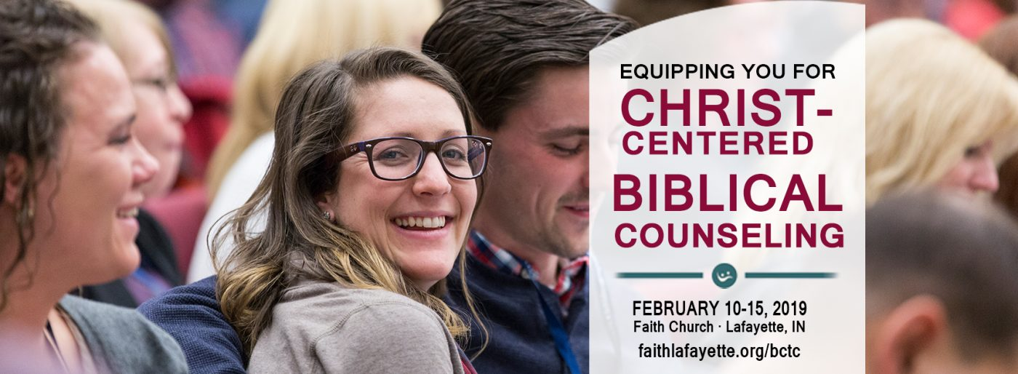
Anyone interested in attending the training conference for Biblical Counseling is encouraged to get signed up! Conference dates are February 10-15, 2019 and travel arrangements have been made – contact Bev Drahos for more information!

Track 1 is now available online! We encourage anyone who is interested in getting involved with our Biblical counseling ministry to either attend the conference in Indiana or check into this online class! Go to biblicalcounseling.com/training-2/online-training.

Email: gracecommbp@gmail.com
Website: gracecommbp.org
Facebook: Grace Community Church
Belle Plaine
Phone: (319) 444-2704

Grace Community
Church

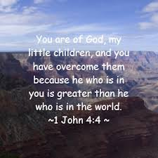

Worship Service
January 5, 2018

Welcome!
Grace Community Church
is delighted that you’ve
joined us for our
Worship Service!

If you’re new to Grace Community,
we invite you to
fill out a Connection Card so we
can get to know you better!
Just place the card in the offering box in the back of the Auditorium.

Anyone interested in receiving biblical counseling can drop a note in the Offering box. We have several counselors at Grace Community who have received training and are able and willing to dig into the scriptures and to work through issues with those who are struggling.
This is a ministry of Grace Community Church and is offered at no charge.

Our Mission:
* To Know Christ
* To Grow in Christ
* To Sow Christ
* To Go into the World with the message of Christ

Scripture:
- 1 John 4:1-6

Four Questions

1.Why must we be _____________________?

2.What is the basis for ______________________________?

3. When is ______________________ (or lack of) evidenced?
- By who we ___________________.
- _________________
- The ____________________.
- By our ____________________ to the ________________________ witness.

4.How do we _________________ when a thing is from God? (How do we __________ the spirits)? (A.W.Tozer)
Answer: How does it affect my __________________ towards:
Memory Verse
1 John 4:4
You, dear children, are from God and have overcome them, because the one who is in you is greater than the one who is in the world.

________________________________________________

Reflection Questions:
1.Can we be biblically discerning (which is good), without being sinfully judgmental (which is bad)? What are some safeguards?

2. Paul praises the Bereans for “examining the Scriptures daily.” (See Acts 17:11). Is that still a praiseworthy endeavor? Why or why not?

