Grace Community
Church

Our vision is to reach our local
community and the world with
the hope and purpose
that Jesus gives.

Jesus comes to each of us and offers,
“Come to Me.”
Here at Grace Community Church,
we want all to feel welcome,
to get to know Christ better,
and follow Him more closely,
then take His message
out into the world.

Please join us!

An offering plate will not be passed
during our church services.
An offering box is in the back of the auditorium, as well as offering envelopes,
if you would like to make a tax-deductible contribution to the ministries of
Grace Community Church
of Belle Plaine.

Easter Eve Service April 20 – 5:00 PM
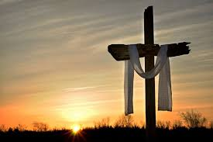

Safe Families Volunteer Training

If you are interested in learning more about being a support person or host family for children in need, please consider attending the upcoming training class!

Saturday, May 4 – 9:00 AM – Noon
Parkview Church North Campus –
70 Kansas Avenue, North Liberty, Iowa
319-383-6647

Email: gracecommbp@gmail.com
Website: gracecommbp.org
Facebook: Grace Community Church
Belle Plaine
Phone: (319) 444-2704

Grace Community
Church

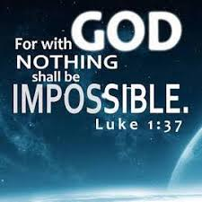

Worship Service
April 6, 2019

Welcome!
Grace Community Church
is delighted that you’ve
joined us for our
Worship Service!

If you’re new to Grace Community,
we invite you to
fill out a Connection Card so we
can get to know you better!
Just place the card in the offering box in the back of the Auditorium.

Anyone interested in receiving biblical counseling can drop a note in the Offering box. We have several counselors at Grace Community who have received training and are able and willing to dig into the scriptures and to work through issues with those who are struggling.
This is a ministry of Grace Community Church and is offered at no charge.

Our Mission:
* To Know Christ
* To Grow in Christ
* To Sow Christ
* To Go into the World with the message of Christ

Scripture:
- Luke 1:26-38

Not the easiest, but the best.

1.The _______________________
- The _________________
- The ____________________
- Gabriel’s _____________________
2. Gabriel’s ________________________
C. The ________________________
D. The ________________________
E. The ________________________

2.The _______________________________

Reflection Questions:
1.Why is the virgin birth of Christ an absolutely essential doctrine of the Christian faith?

2.What does submission to God look like in your life? That is, are there things that must change in your life?

Additional Notes:

Memory Verse
Luke 1:37
For with God, nothing shall be impossible.

