Grace Community
Church

Our vision is to reach our local
community and the world with
the hope and purpose
that Jesus gives.

Jesus comes to each of us and offers,
“Come to Me.”
Here at Grace Community Church,
we want all to feel welcome,
to get to know Christ better,
and follow Him more closely,
then take His message
out into the world.

Please join us!

An offering plate will not be passed
during our church services.
An offering box is in the back of the auditorium, as well as offering envelopes,
if you would like to make a tax-deductible contribution to the ministries of
Grace Community Church
of Belle Plaine.

Friends Day
If you are a friend visiting tonight, we welcome you to Grace Community Church! We hope the service is meaningful to you and that you will come again!

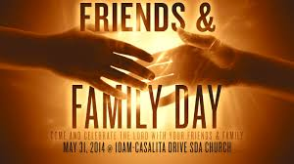

East Iowa Bible Camp – Register Now
Summer camp is for all age groups–first grade through high school. Register and pay in full before March 31, to receive $50 off and a free t-shirt! Summer camp is a wonderful way for children to grow closer to God and form life-long friendships – and have tons of fun doing it! Register at www.loveeibc.org/summer-camp

Email: gracecommbp@gmail.com
Website: gracecommbp.org
Facebook: Grace Community Church
Belle Plaine
Phone: (319) 444-2704

Grace Community
Church

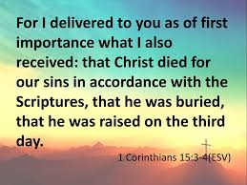

Worship Service
March 16, 2019

Welcome!
Grace Community Church
is delighted that you’ve
joined us for our
Worship Service!

If you’re new to Grace Community,
we invite you to
fill out a Connection Card so we
can get to know you better!
Just place the card in the offering box in the back of the Auditorium.

Anyone interested in receiving biblical counseling can drop a note in the Offering box. We have several counselors at Grace Community who have received training and are able and willing to dig into the scriptures and to work through issues with those who are struggling.
This is a ministry of Grace Community Church and is offered at no charge.

Our Mission:
* To Know Christ
* To Grow in Christ
* To Sow Christ
* To Go into the World with the message of Christ

Scripture:
- Luke 1:1-4
- 1 Corinthians 15:1-8

What I Believe Determines How I Live

1.Our ______________: God’s word.
- We have become ________________________.
- _____________________
- _____________________
- We know how we’ll be _______________________.

2.Our _________________________.
- We believe the _______________________ are the ______________________ words of God.
- If it is God’s Word, then it’s __________________.

3.Our _____________________: Why it’s convincing.
- It’s _______________ in history.
- It’s too ________________-__________________.
- It’s too _________________________.

4.Our ______________________: What we’re _____________________.

Reflection Questions:
1.Following Jesus does not guarantee health, wealth or a life of ease; rather, we are given a cross. (Luke 9:23) Why would anyone choose to pick up cross and follow Jesus?

2.Is there anything so precious to you that you would follow it instead of following Jesus? In the end, what remains?

Memory Verse
2 Corinthians 15:3-4
For what I received, I passed on to you as of first importance: that Christ died for our sins, according to the scriptures, that he was buried, that he was raised on the third day according to the scriptures…

