Safe Families Volunteer Training

If you are interested in learning more about being a support person or host family for children in need, please consider attending the upcoming training class!

Saturday, May 4 – 9:00 AM – Noon
Parkview Church North Campus –
70 Kansas Avenue, North Liberty, Iowa
319-383-6647

Grace Community
Church

Our vision is to reach our local
community and the world with
the hope and purpose
that Jesus gives.

Jesus comes to each of us and offers,
“Come to Me.”
Here at Grace Community Church,
we want all to feel welcome,
to get to know Christ better,
and follow Him more closely,
then take His message
out into the world.

Please join us!

An offering plate will not be passed
during our church services.
An offering box is in the back of the auditorium, as well as offering envelopes,
if you would like to make a tax-deductible contribution to the ministries of
Grace Community Church
of Belle Plaine.

Type to enter a caption.

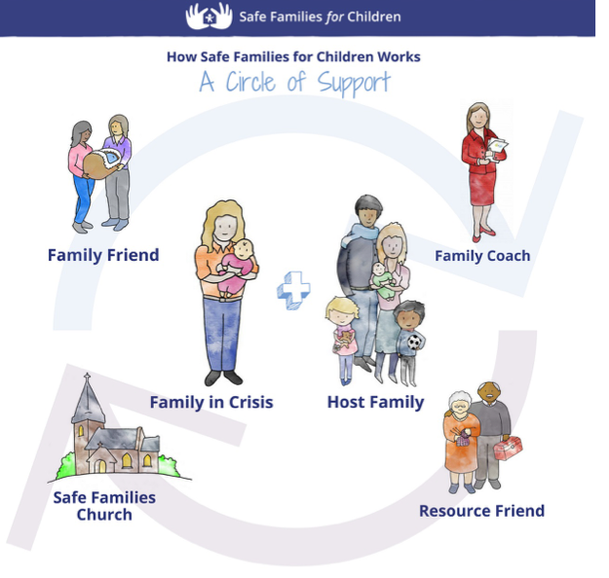

Email: gracecommbp@gmail.com
Website: gracecommbp.org
Facebook: Grace Community Church
Belle Plaine
Phone: (319) 444-2704

Grace Community
Church

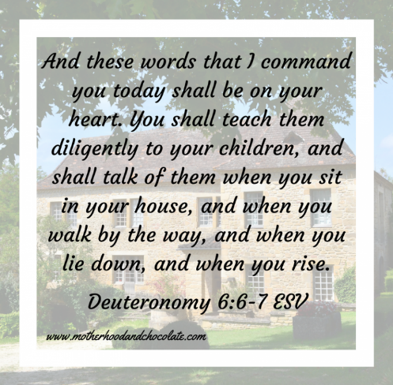

Worship Service
April 27, 2019

Welcome!
Grace Community Church
is delighted that you’ve
joined us for our
Worship Service!

If you’re new to Grace Community,
we invite you to
fill out a Connection Card so we
can get to know you better!
Just place the card in the offering box in the back of the Auditorium.

Anyone interested in receiving biblical counseling can drop a note in the Offering box. We have several counselors at Grace Community who have received training and are able and willing to dig into the scriptures and to work through issues with those who are struggling.
This is a ministry of Grace Community Church and is offered at no charge.

Our Mission:
* To Know Christ
* To Grow in Christ
* To Sow Christ
* To Go into the World with the message of Christ

Scripture:
- Luke 1:57-80

The Supreme Achievement in any Career

Sermon Notes:

1.Zechariah: ____________________, ________________ and ___________________.
- __________________ - doubt
- __________________ - he leads his family __________________
- _______________________ - concerning his _________________ and his _______________.

2. Four _________________ related to salvation, and one ___________________.
- Sense of the ____________________ of God.
- Personal _________________________.
- ___________________ of salvation.
- _________________ that others might _______________ it.
- Changed __________________ in life.

3. ________________________ of God in a __________________ culture.
- __________________.
- __________________.
- __________________.

Reflection Questions:

1.How can we help people who don’t know Christ see their desperate condition? (hint: Galatians 3:10, 24)

2.Have you ever considered the tender mercy of God? What is standing in the way of receiving it for yourself?

Memory Verse

Deuteronomy 6:6-7
And these words that I command you today shall be on your heart. You shall teach them diligently to your children, and shall talk of them when you sit in your house, and when you walk by the way, and when you lie down and when you rise.

