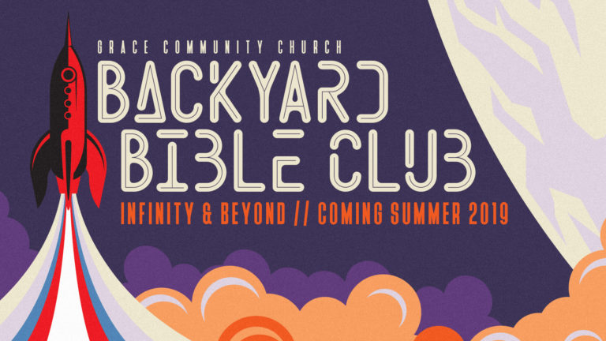
Bible Club Registration Form
• Belle Plaine • August 7-10 • 5:30-7:00 pm
Corner of 1st Avenue and Hwy 21
There is no registration fee – this is a free event!
Register at gracecommbp.org or mail form to:
Grace Community Church • 404 3rd St., Belle Plaine, Iowa 52208
Questions: gracecommbp@gmail.com, 319-444-2704

Parent/Guardian (First & Last Name) ____________________________________________________________________________
Address ________________________________________________ City______________________________ Zip_____________________
Primary Contact Phone ____________________________ Secondary Contact Phone ___________________________________
Parent/Guardian E-mail __________________________________________________________________________________________
Home Church: Grace Community Church None Other _______________________________________________

Emergency contact: (If DIFFERENT from Parent/Guardian above)
Name __________________________________ Relationship to Child _________________________________ Phone __________________________________

Child’s Name __________________________________________________ Age ______ Grade in Fall of 2019 ________________
Child’s Name __________________________________________________ Age ______ Grade in Fall of 2019 ________________
Child’s Name __________________________________________________ Age ______ Grade in Fall of 2019 ________________
Allergies / Medical Concerns: Yes No Please Explain: _______________________________________________________________________ Permission to use child’s photograph
Yes No I give permission to Grace Community Church to photograph my child at Backyard Bible Club. I give permission to copyright, use and publish the photographs for any lawful purpose, including newspaper articles, church publications, the church website and Facebook page.
Medical Release
My permission is granted for Grace Community Church volunteers while at Backyard Bible Club, to obtain necessary medical attention in case of sickness or injury for the child(ren)'s name(s) listed above. I, the undersigned, do hereby release, remiss or forever discharge all volunteers of Grace Community Church from any and all claims, demands, actions or cause of action, past, present or future arising out of any damage or injury while participating in Backyard Bible Club.

Parent Signature ___________________________________________________________________________ Date _____________________________

