Grace Community Church
Backyard Bible Club

Backyard Bible Club is being “revamped” this year to provide families with crafts, snacks, links to songs/lessons, and everything you need to stage your own Backyard Bible Club for your family - or neighborhood, if you wish ! We are trying to do our best to maintain social distance and yet provide families with all the resources they will need to give their children a great experience, even if it’s not with crowds of kiddos! “Family Packs” are ready! If you have any questions, please feel free to contact us on Facebook, or call Sheri Drahos (319-310-5822).

Our vision is to reach our local
community and the world with
the hope and purpose
that Jesus gives.

Jesus comes to each of us and offers,
“Come to Me.”
Here at Grace Community Church,
we want all to feel welcome,
to get to know Christ better,
and follow Him more closely,
then take His message
out into the world.

Please join us!

An offering plate will not be passed
during our church services.
An offering box is in the back of the auditorium, as well as offering envelopes,
if you would like to make a tax-deductible contribution to the ministries of
Grace Community Church
of Belle Plaine.

Facebook:
Grace Community Church-Belle Plaine

Grace Community Church of Belle Plaine
Website: gracecommbp.org
Email: gracecommbp@gmail.com
Phone: (319) 310-5822
(Sheri Drahos)

Grace Community
Church

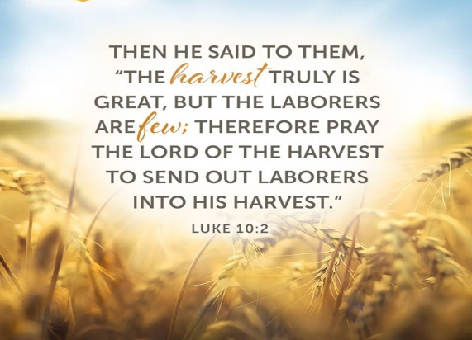

Worship Service
July 25, 2020

Welcome!
Grace Community Church
is delighted that you’ve
joined us for our
Worship Service!

If you’re new to Grace Community,
we invite you to
fill out a Connection Card so we
can get to know you better!
Just place the card in the offering box in the back of the Auditorium.

Anyone interested in receiving biblical counseling can drop a note in the Offering box. We have several counselors at Grace Community who have received training and are able and willing to dig into the scriptures and to work through issues with those who are struggling.
This is a ministry of Grace Community Church and is offered at no charge.

Our Mission:
* To Know Christ
* To Grow in Christ
* To Sow Christ
* To Go into the World with the message of Christ

Scripture
- Luke 10:1-8

Labor Shortage

1. ______________________ by Jesus
- The __________________
- The __________________

2. _____________ by ______________

3. ___________________ of the Kingdom
- You ______________________
- God ____________________ growth

4. No _____________________ of work

5. ________________ shortage

6. The _________________________
Memory Verse
Luke 10:2
Then He said to them, “The harvest is plentiful, but the laborers are few. Ask the Lord of the harvest, therefore, to send out workers into His harvest field.

7. The second __________________________

8. Learning ____________________________

9. _____________________________

10. Just ____________ it

1. Feeling ________________ to eat.

Reflection/Discussion Questions:

1. Why are the workers few? What has kept you from participating in the harvest?

2. Why is God the main recruiter instead of church leaders? What are we instructed to do when we need more workers?

3. Do you dare to pray that you become a harvester?

