Grace Community
Church

Our vision is to reach our local
community and the world with
the hope and purpose
that Jesus gives.

Jesus comes to each of us and offers,
“Come to Me.”
Here at Grace Community Church,
we want all to feel welcome,
to get to know Christ better,
and follow Him more closely…
then take His message
out into the world.

Please join us!

An offering plate will not be passed
during our church services.
An offering box is in the back of the auditorium, as well as offering envelopes,
if you would like to make a tax-deductible contribution to the ministries of
Grace Community Church
of Belle Plaine.

New Year’s Eve, Eve, Eve Party!
Tonight!
December 29, 2018
Join us for food, games and lots of family fun as we celebrate the old year and look forward to what next year brings!

Email: gracecommbp@gmail.com
Website: gracecommbp.org
Facebook: Grace Community Church
Belle Plaine
Phone: (319) 444-2704

Grace Community
Church

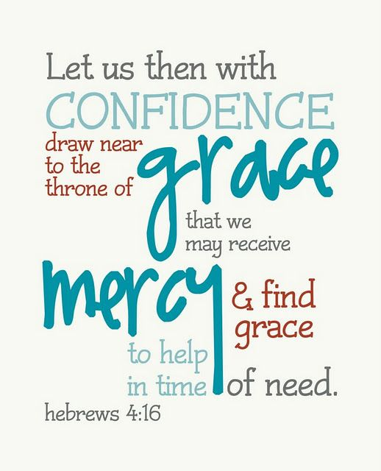

Worship Service
December 29, 2018

Welcome!
Grace Community Church
is delighted that you’ve
joined us for our
Worship Service!

If you’re new to Grace Community,
we invite you to
fill out a Connection Card so we
can get to know you better!
Just place the card in the offering box in the back of the Auditorium.

Anyone interested in receiving biblical counseling can drop a note in the Offering box. We have several counselors at Grace Community who have received training and are able and willing to dig into the scriptures and to work through issues with those who are struggling.
This is a ministry of Grace Community Church and is offered at no charge.

Our Mission:
* To Know Christ
* To Grow in Christ
* To Sow Christ
* To Go into the World with the message of Christ

Scripture:
- 1 John 3:19-24

Rest and Confidence
in a Broken World

Sermon Notes:

1.The basis of our _________________________
- What ____________ know.
- What _____________ knows.
So, be __________________.

2.Our overall _______________.
- God’s _______________ in our lives.
- ______________ our failures.
So, be __________________________.

3. Confidence leads to two _______________________.
- _________________________ prayer.
Memory Verse
Hebrews 4:16
Let us therefore come boldly to the throne of grace that we may obtain mercy and find grace to help in time of need.

- The abiding ___________________________ through the Spirit.

4. The result of rest and confidence is _____________________.
- In _______________________.
- In _______________________.
- In _______________________.

Reflection Questions:
1.How can we know whether feelings of guilt stem from the devil’s accusations or from the Holy Spirit’s conviction?

2. Where is the proper balance between accepting our human limitations, but not tolerating sin or spiritual immaturity?

