Christmas Eve Service
December 24
5:00 PM
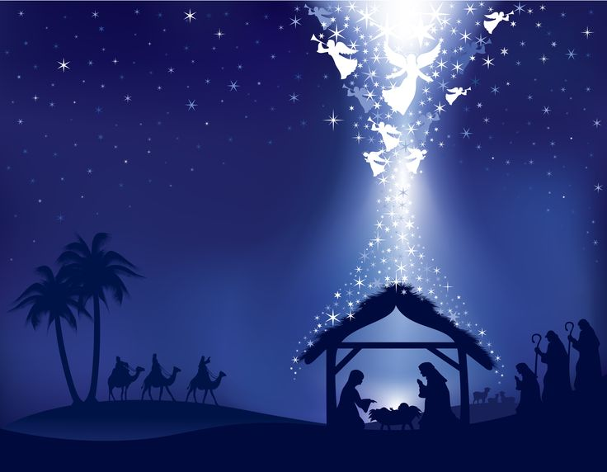
Grace Community
Church

Our vision is to reach our local
community and the world with
the hope and purpose
that Jesus gives.

Jesus comes to each of us and offers,
“Come to Me.”
Here at Grace Community Church,
we want all to feel welcome,
to get to know Christ better,
and follow Him more closely…
then take His message
out into the world.

Please join us!

An offering plate will not be passed
during our church services.
An offering box is in the back of the auditorium, as well as offering envelopes,
if you would like to make a tax-deductible contribution to the ministries of
Grace Community Church
of Belle Plaine.

New Year’s Eve, Eve, Eve Party!
December 29, 2018
Join us for food, games and lots of family fun as we celebrate the old year and look forward to what next year brings!
A-F—Bring a Soup
G-M—Bring a dessert
N-Z—Bring an appetizer

Email: gracecommbp@gmail.com
Website: gracecommbp.org
Facebook: Grace Community Church
Belle Plaine
Phone: (319) 444-2704

Grace Community
Church

Worship Service
December 22, 2018

Welcome!
Grace Community Church
is delighted that you’ve
joined us for our
Worship Service!

If you’re new to Grace Community,
we invite you to
fill out a Connection Card so we
can get to know you better!
Just place the card in the offering box in the back of the Auditorium.

Anyone interested in receiving biblical counseling can drop a note in the Offering box. We have several counselors at Grace Community who have received training and are able and willing to dig into the scriptures and to work through issues with those who are struggling.
This is a ministry of Grace Community Church and is offered at no charge.

Our Mission:
* To Know Christ
* To Grow in Christ
* To Sow Christ
* To Go into the World with the message of Christ

Scripture:
- Revelation 21:1-7

The Hope

Sermon Notes:

Five Aspects of Heaven
- The _______________ of heaven.
- A ___________________.
- A ___________________.
- A ___________________.

Heaven is the new __________________.

- The _____________________ of heaven.
Memory Verse
Revelation 21:4
He will wipe every tear from their eyes. There will be no more death, mourning, or crying or pain. For the old order of things has passed away.

- The ______________________ of heaven.

- The ______________________ of heaven.

- The ______________________ of heaven.

The Ultimate Hope:
_________________ _____________ _____________.

Reflection Questions:
1.For more in-depth study on heaven, see Randy Alcorn’s book: “Heaven”.

2. Chronicles of Narnia by C.S. Lewis is not just for children! (Although children love it!). It’s one of the best fiction series available with lots of spiritual truths woven throughout.

